**National University of Computer & Emerging Sciences**

**Karachi Campus**



**BUDGET MANAGEMENT PROGRAM**

**Project Proposal**

**Programming Fundamentals**

**Section: BSE-1A**

**Group Members:**

**23K-3032 Shah Hunain**

**23K-3041 Abdul Hadi**

**23K-3008 Yasbah Ali**

Project Proposal

* **Introduction**

**“BUDGET MANANGEMENT PROGRAM”**



* **What is a budget management program?**
* **What will it do?**

Managing the budget and having a sharp watch on it is very important, especially when it comes to the limited income. Our budget tracker will help the user to know where does all the expenses really go also allowing the user to decrease his/her extra accessories and moving with what really important is with help of the generated monthly expense total.

Our **BUDGET MANAGEMENT PROGRAM** provides the user to enter his/her daily expenses in different locations i.e., daily expenses for week 1 (Monday, Tuesday, Wednesday, Thursday, Friday, Saturday, Sunday) and by the end of the month, it will generate the total expense of the user and give remark keeping in view the salary of the user.

* **Existing System**

There are various existing systems related to budget management which perform similar tasks.

* **For example:**

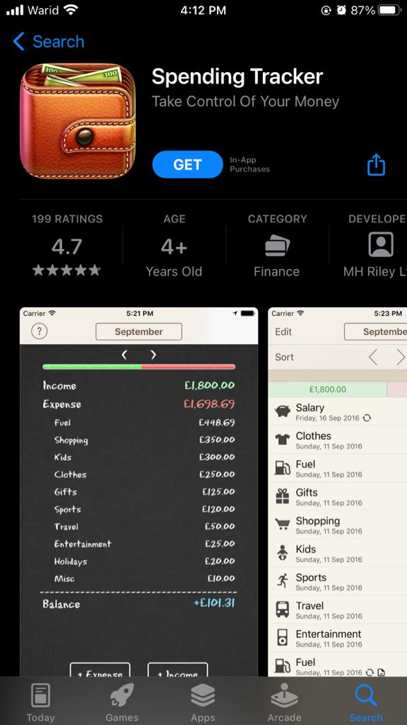

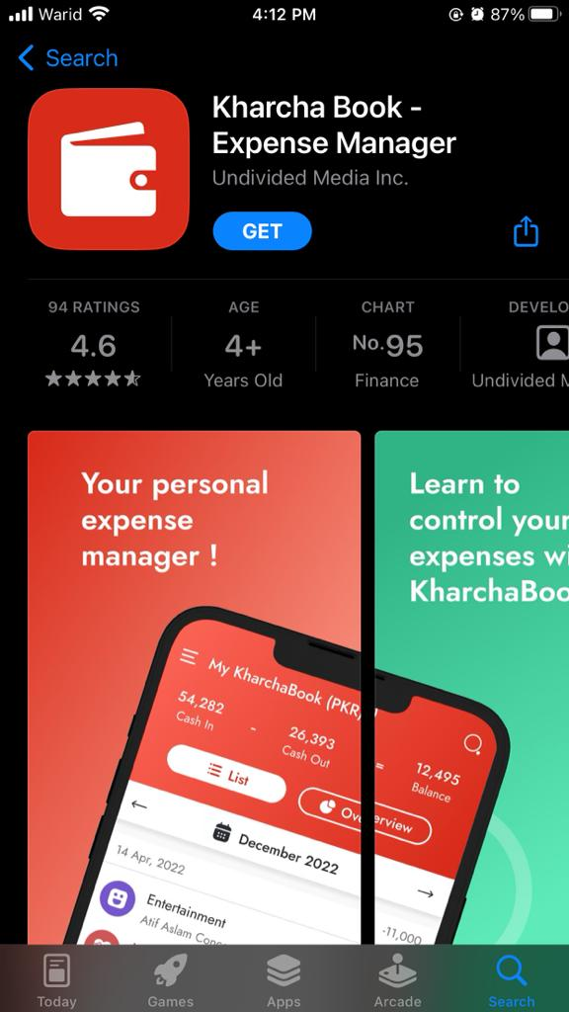

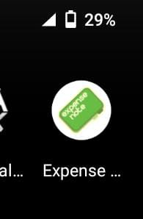

It takes the input from the user regarding the expenses he/she makes. The user can enter expenses either just in month book or in a proper daily schedule and at the end of the month the user can review all the expenses he/she had made the entire month.

* **Problem Statement**

Many negative reviews have been reported from user’s end. These existing applications lack planning for expenses, there is no limit for expenditure; often the income is finished much before the month end and users get the notification alert just before their income is about to finish. These apps lack the savings feature so the users are completely dependent on credit cards which results in huge bills which are deducted from their next income, and they face the same issue repeatedly.

Following are the discrepancies in existing system:

* Lack of early alert notification
* Lack of managing credit bills
* Lack of saving feature
* Lack of limit set for expenditure
* **Proposed Solution**

Our system will be introducing some features that will help users in managing his/her monthly budget with ease.

* **Introducing weekly system:**

Our system will have a weekly budget control system. Firstly, the expenses of utility bills and taxes will be deducted from income then income will be divided into 4 parts for 4 weeks.

* **Limiting expenditures and alert notifications:**

The system will set the limit to the amount set for each week and 10% of the amount of each week will go into saving. If the user has consumed 80% amount of the weekly amount before the weekend it will send an alert notification.

* **Managing credit bills:**

If the user consumes all the weekly amount, then he will switch to credit which will result in lower credit bills and can also be managed by savings.

* **Introducing AI system:**

The system will suggest to the user time to time if he/she is making extra expenditure, for example if user has recently inserted data for expenditure on shopping and now of amusement system will show an alert that you have spent much on extras this week, so limit your extras for upcoming weeks.

* **SALIENT FEATURES**

The proposed program aims to provide the following features to the users:

1. **Store User’s Source of Income:**
   * Monthly Income through a Job.
   * Monthly Income through any Investments.
   * Monthly Income through any Business.
   * Other Sources of Income.
2. **Store User’s Expenditure On:**
   * Utility bills (Electricity, Natural Gas, Water, Telephone, Internet, etc.).
   * House Rent.
   * Transportation.
   * Amusement.
   * Food and Grocery.
   * Shopping.
   * Credit Card Bills.
   * Any other Expenditure.
3. **Calculation Of Taxes On:**
   * User’s Monthly Income.
   * User’s Shopping, Credit Card, Food and Grocery.
   * Purchase of Expensive Items.
   * Other Taxes Imposed by the Government.
4. **Provide Monthly and Annual Statement of User’s Activity:**

* Capital Raised by the user.
* Expenditure of the user.
* Outstanding Balance or Remaining Balance.

1. **Generate Alerts to The User On:**

* Payment of Utility Bills.
* Payment of Monthly Rent.
* Transactions using Credit Card.

1. **Send Reminder to The User For:**

* Unpaid Utility Bills.
* Unpaid Taxes to be Paid.
* Unpaid Credit Card Bills.
* Unpaid House Rent.
* Any other Amount Due.

1. **Personalized Advise for The User:**

* Provide the User with Investment Options.
* Provide Tips to Maintain Budget.
* Notify about New Income Opportunities.
* Notify on any Available Discount.
* Provide User with Videos from Expert Project Advisors.
* Provide Motivational Quotes to the User.
* **TOOLS & TECHNOLOGIES**

**Programming Language:**

The proposed program will make use of the renowned **Programming Language C**. The language provides the user with useful features such as Selection Statements, Looping Structures and Arrays, which will cater to the development of an efficient budget program.

**Framework:**

A framework is referred to as a structure or a platform which provides help to build a software program such as, Visual Code, Code Blocks and DevC++. The library functions and header file included in these software provide the actual framework to the user such as the <stdio.h> and <conio.h> header file which we include in the beginning of our codes. They include functions which are repetitive, for example printf and scanf functions, thus saving the user time.

The chosen Integrated Development Environment (IDE) used for the development of the proposed project is DevC++ and the header files <stdio.h>, <conio.h>, and <math.h> will be included.

**Operating System:**

The well-known and famous operating system Microsoft Windows 10 will be used to develop the proposed project.